
FINANCE DEPARTMENT | TREASURY DIVISION
DAP E-PAYMENT SYSTEM
Operations Manual and System Documentation
Version 3.0
Platform: Google Workspace (Apps Script, Sheets, Drive)
Integration: LANDBANK WeAccess (Institutional Banking)
Development Academy of the Philippines
DAP Building, San Miguel Avenue, Ortigas Center, Pasig City
Last Updated: January 2026 • For Internal Use Only

Document Control
Field | Information
Document Title | DAP E-Payment System – Operations Manual and System Documentation
System Version | E-Payment System v3
Document Owner | Finance Department – Treasury Division
Process Owners | Accounting Division; Treasury Division; System Administrator
Effective Date | January 2026
Classification | Internal Use Only – contains descriptions of financial controls
Review Cycle | Annually, or whenever the system, bank requirements or BIR forms change

Revision History
Version | Date | Description of Change | Prepared By
3.0 | January 2026 | Operations manual for E-Payment System v3, formatted and expanded with procedures, status lifecycle, maintenance schedule and appendices. | Treasury Division

Review and Approval
Role | Name | Signature | Date
Prepared by:
System Developer / Treasury Division
Reviewed by:
Chief, Accounting Division
Reviewed by:
Chief, Treasury Division
Approved by:
Director, Finance Department
Table of Contents
1. Introduction 4
1.1 Purpose 4
1.2 Scope 4
1.3 Intended Users 4
1.4 Definitions and Acronyms 4
2. Executive Summary 6
2.1 The Challenge 6
2.2 The Solution 6
2.3 Expected Benefits 6
3. System Architecture 7
3.1 Technical Stack 7
3.2 Logical Data Flow 7
3.3 Drive Folder Structure 7
4. User Roles and Access Control 8
4.1 Logging In 8
4.2 Requesting an Account 8
5. Data Dictionary 10
5.1 Master_DV_List (The Ledger) 10
5.2 Payee_Database (Source of Truth) 10
5.3 SDO_PCF_Accounts (The "Ghost" Logic) 10
5.4 Tax_Cert_Data 11
5.5 Supporting Sheets 11
6. Transaction Status Lifecycle 12
7. Operational Procedures: The Six-Stage Lifecycle 13
7.1 Stage 1: Ingestion and Intelligent Validation (Accounting) 13
7.2 Stage 2: Tax Compliance – BIR Form 2307 (Parallel Workflow) 14
7.3 Stage 3: Batching (Treasury) 17
7.4 Stage 4: The Bridge – Bank Interoperability 18
7.5 Stage 5: Finalization and Payout (Treasury) 20
7.6 Stage 6: Recording – Handoff to Accounting 23
8. Protocols and Sub-Systems 24
8.1 The SDO "Ghost" Protocol 24
8.2 Payee Enrollment System 24
8.3 Internal Payee Management and HRIS Reconciliation 27
8.4 Security and Authentication 27
9. Troubleshooting Guide 28
10. Maintenance and Configuration 29
10.1 System Limits 29
10.2 Folder Structure 29
10.3 Templates 29
10.4 Routine Maintenance Schedule 29
10.5 Business Continuity 29
11. Data Privacy and Records Management 30
Appendix A. Transaction Type Classification 31
Appendix B. JEV Account Codes and ATC Mapping 32
Appendix C. FINDES File Format 33
List of Figures
Figure 1. DAP Treasury E-Payment System login page
Figure 2. Accounting Web App – Disbursement Voucher Upload
Figure 3. Accounting Web App – Tax Certificate Management
Figure 4. System-generated draft BIR Form 2307
Figure 5. Tax Certificate Approval Request email
Figure 6. Action Confirmed email with the signed BIR Form 2307
Figure 7. Treasury Hub – For Batching tab
Figure 8. Request for WeAccess Approval email sent to Authorized Signatories
Figure 9. Endorsement email – Breakdown Summary
Figure 10. Endorsement email – batch totals and attached Payroll Register and DVs
Figure 11. System-generated Annex H – Daily Report of E-Payments from Agency Account
Figure 12. Fund Transfer Confirmation email received by the payee
Figure 13. Payee email attachments – Disbursement Voucher and signed BIR Form 2307
Figure 14. For Recording email with the batch package
Figure 15. DAP Resource Person/Consultant's LandBank Account Enrollment form
Figure 16. Admin Dashboard – External Enrollment, Pending HR Validation
Figure 17. Enrollment Details – HR submission to Admin
Figure 18. Enrollment Details – Admin approval
Figure 19. Notice of Successful Enrollment email

1. Introduction

1.1 Purpose
This manual establishes the standard operating procedures for the DAP E-Payment System (v3). It documents how Disbursement Vouchers (DVs) are received, validated, batched, transmitted to LANDBANK WeAccess, verified against bank records, paid out, and turned over to the Accounting Division for recording. It also serves as the technical reference for the people who maintain the system.

1.2 Scope
The manual covers every electronic disbursement processed through the E-Payment System, from the upload of a DV PDF by the Accounting Division to the release of the batch package for Journal Entry Voucher (JEV) recording. It also covers the supporting sub-systems: BIR Form 2307 generation, payee enrollment, Special Disbursing Officer (SDO) account handling, user access and system maintenance.
Approval of fund transfers inside the LANDBANK WeAccess portal is governed by the bank's own procedures and by DAP's signatory rules. This manual refers to those steps only where the system hands work over to the portal or receives output from it.

1.3 Intended Users
- Accounting Division staff – upload DVs, review and sign Tax Certificates, and record completed batches.
- Treasury Division staff – create batches, generate bank files, validate bank registers, and finalize payments.
- Authorized Signatories – approve fund transfers in LANDBANK WeAccess upon endorsement.
- HR personnel – validate employment details of payees during enrollment.
- System Administrator – manages user accounts, payee and SDO records, templates and configuration.

1.4 Definitions and Acronyms
Term | Definition
ATC | Alphanumeric Tax Code assigned by the BIR to each type of withholding (e.g., WI050, WI051).
Annex H | Daily Report of E-Payments from Agency Account, prescribed under COA Circular No. 2021-014.
Batch | A group of DVs processed and transmitted to the bank as one transaction, identified by a Batch No. in the format YYYY-MM-NNNN.
BIR Form 2307 | Certificate of Creditable Tax Withheld at Source issued to payees subject to expanded withholding tax.
CSM Survey | Client Satisfaction Measurement survey sent to payees after payment.
Debit Memo | Bank document confirming that the agency account was debited for the batch.
DV | Disbursement Voucher generated by the FMIS.
EWT | Expanded Withholding Tax.
FINDES | The fixed-format CSV file required by LANDBANK WeAccess for bulk credit to payee accounts.
FMIS | DAP's internal Financial Management Information System.
HRIS | Human Resource Information System; the HRIS ID is the employee number.
JEV | Journal Entry Voucher.
OCR | Optical Character Recognition; conversion of PDF images to readable text.
PCF | Petty Cash Fund.
Payroll Register | The PDF report produced by WeAccess after a FINDES file is uploaded, listing each credit to be made.
SDO | Special Disbursing Officer, an employee designated to hold and disburse a cash fund.
TRN | Transaction Reference Number assigned by WeAccess to an uploaded batch.
WeAccess | LANDBANK's institutional internet banking platform.

2. Executive Summary

2.1 The Challenge
The Development Academy of the Philippines (DAP) faced a critical operational gap: the lack of interoperability between its internal Financial Management Information System (FMIS) and the LANDBANK WeAccess System (Institutional Banking Application). This disconnect resulted in:
- Forced manual encoding – Finance staff manually typed hundreds of payee names, account numbers and amounts into the bank portal for every payment run.
- Control vulnerabilities – Manual re-keying introduced the risk of wrong account numbers or amounts, with no independent check between what was approved in the DV and what was sent to the bank.
- Process bottlenecks – Approval requests, payment confirmations and tax certificates were prepared and emailed one by one, delaying both payment and the issuance of BIR Form 2307.

2.2 The Solution
The DAP E-Payment System v3 is a secure, automated middleware solution built entirely within DAP's Google Workspace environment. It requires no additional servers or licenses and acts as a bridge that:
- Ingests and validates – reads Disbursement Vouchers (DVs) through OCR to extract and verify payee, amount and tax data.
- Translates – converts internal data into the bank-compliant FINDES file format.
- Audits – automatically cross-references the bank's Payroll Register against internal records before any fund transfer is approved.
- Distributes – automates the emailing of endorsements, payment notifications, signed Tax Certificates (BIR Form 2307) and CSM survey links.

2.3 Expected Benefits
Area | Benefit
Accuracy | Account numbers and amounts are taken from validated records, not re-typed, and are checked against the bank's own register.
Speed | A batch of dozens of payees can be prepared, endorsed and finalized in minutes.
Compliance | Annex H and BIR Form 2307 are produced automatically and consistently.
Transparency | Payees are notified of every credit and receive their tax certificate with the confirmation.
Audit trail | Every DV, bank file, register and report is stored in a structured Drive folder per batch.

3. System Architecture
The system uses a "Traffic Controller" architecture: a single web application entry point authenticates each user and routes them to the dashboard for their role. It is a serverless application that runs on Google's cloud infrastructure under DAP's Workspace account.

3.1 Technical Stack
Layer | Technology | Function
Frontend | HTML5 / CSS3 / JavaScript (Google Apps Script HtmlService) | Login page and the Accounting, Treasury and Admin dashboards.
Backend | Google Apps Script (server-side JavaScript) | Routing, validation, file generation, email distribution.
Database | Google Sheets | Master_DV_List, Payee_Database, User_Database, SDO_PCF_Accounts, Tax_Cert_Data, Enrollment_Requests, Config.
File storage | Google Drive | DV PDFs, FINDES files, bank registers, Annex H and 2307 PDFs, organized by Year > Month > Batch.
OCR engine | Google Drive API | Converts uploaded PDFs to text for data extraction.
Email | Gmail (MailApp) | Approval requests, endorsements, payee notifications.
Authentication | Custom session management with SHA-256 password hashing | Role-based login and session control.

3.2 Logical Data Flow
User (Browser) ⇄ Google Apps Script (Router) ⇄ Google Sheets (Database) / Google Drive (Files)
The system exchanges data with LANDBANK WeAccess through files only. Treasury uploads the FINDES file to the portal and downloads the Payroll Register and Debit Memo from it. The system has no direct connection to the bank, so bank credentials never pass through Google Workspace.

3.3 Drive Folder Structure
The system creates and maintains the following structure automatically. Folder IDs for the root folders are stored in the Config sheet.
Folder | Contents
Incoming | Temporary location for newly uploaded DV PDFs during OCR and validation.
Processed / [Year] / [MM-Month] / BATCH-[Batch No.] | DVs, FINDES CSV, Payroll Register, Debit Memo, Annex H and signed 2307s for each batch (e.g., Processed / 2026 / 01-January / BATCH-2026-01-0015).
Archive | Spreadsheets of completed transactions removed from the Master_DV_List by the archiving routine.

4. User Roles and Access Control
Access is strictly role-based. After login, users are routed to the dashboard for their assigned role and can perform only the functions listed below.
Role | Dashboard | Responsibilities
Accounting | Accounting Web App | Data ingestion. Uploads DVs, reviews Tax Certificates, approves or rejects drafts, records completed batches.
Treasury | Treasury Hub | Batch processing. Creates batches, generates FINDES files, validates bank registers, requests endorsement and finalizes payments.
Admin | Admin Web App (or Treasury Hub) | System control. Manages user accounts, payee enrollment, SDO accounts, HRIS reconciliation and system configuration.

4.1 Logging In
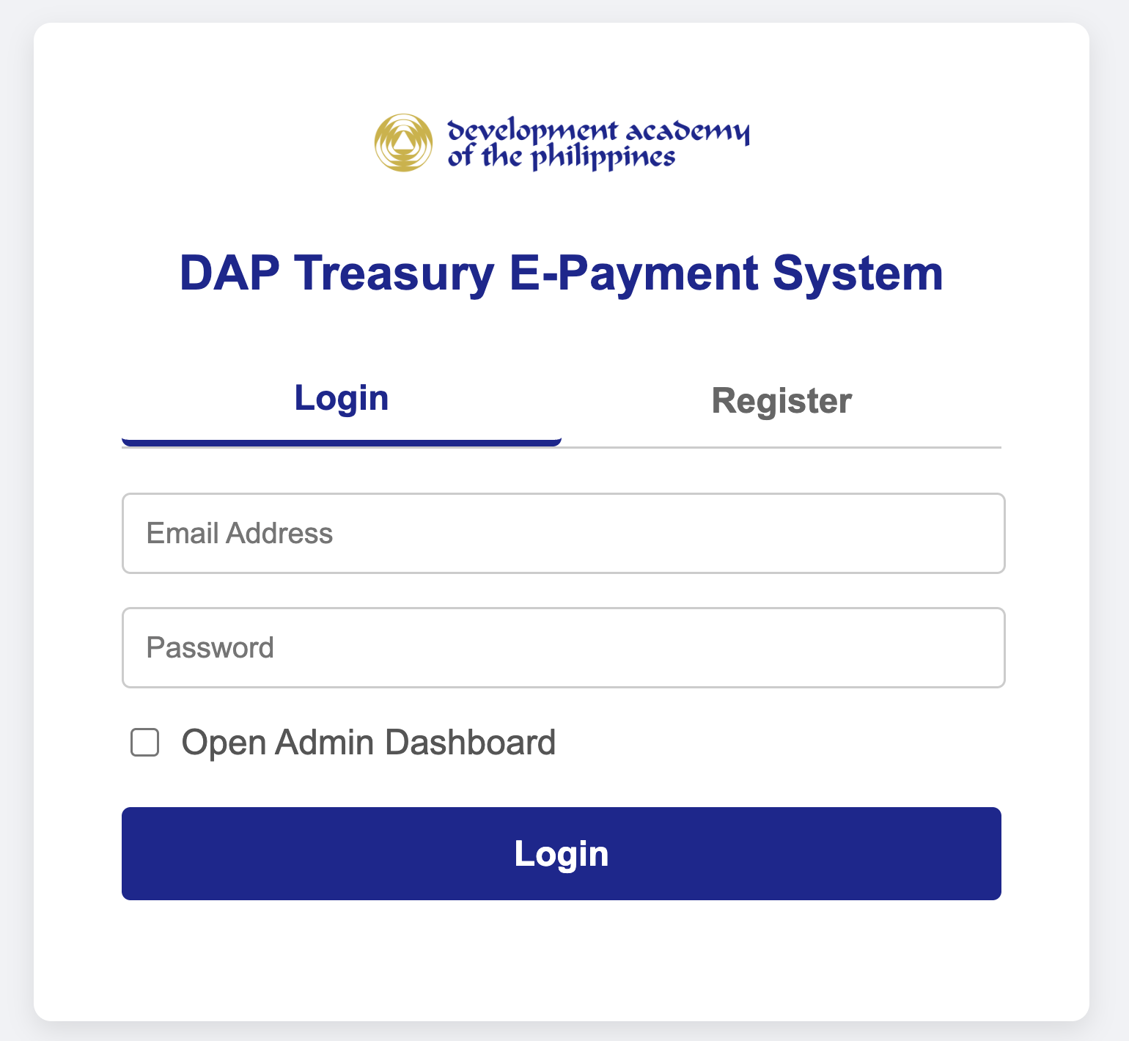
Figure 1. DAP Treasury E-Payment System login page
- Open the E-Payment System web application link provided by the System Administrator.
- Enter your registered DAP Email Address and Password.
- Administrators who want the Admin Dashboard instead of the Treasury Hub tick Open Admin Dashboard.
- Click Login. The system verifies your credentials and redirects you to your dashboard.
- When finished, click Logout on the upper right of the dashboard. Do not simply close the browser on a shared computer.

4.2 Requesting an Account
New users click Register on the login page and submit their email and password. The account is created with the status "Pending Approval" and cannot be used until the System Administrator assigns a role and sets the status to "Active" in the User_Database.
NOTE: Sessions expire automatically after 8 hours. If your dashboard stops responding or returns you to the login page, log in again.

5. Data Dictionary
The system relies on Google Sheets that act as relational database tables. Column headers are read by name, so they must not be renamed.

5.1 Master_DV_List (The Ledger)
Stores every transaction processed by the system.
Field | Description
DV No | Unique identifier taken from the voucher.
Payee Name | Beneficiary name, matched against Payee_Database.
Amount Due | Net amount to be transferred.
Transaction Type | Classification derived from the DV particulars (see Appendix A).
Status | Current state of the transaction (see Section 6).
Batch No | Group ID assigned by Treasury (YYYY-MM-NNNN).
WeAccess Ref No | TRN assigned by LANDBANK WeAccess to the batch.
PDF_Link | URL of the original DV file in Drive.
JEV No | Journal Entry Voucher number.
Timestamp | Date and time the DV was uploaded; used by the archiving routine.

5.2 Payee_Database (Source of Truth)
Stores verified banking details of enrolled payees.
Field | Description
Name | Unique key in "SURNAME, FIRST NAME" format. Must match the name on the HRIS and DV.
Landbank Account No | 10-digit LANDBANK account number.
Email Address | Destination of payment notifications and tax certificates.
HRIS ID | Employee number (for employees).

5.3 SDO_PCF_Accounts (The "Ghost" Logic)
Stores the separate custodial accounts of Special Disbursing Officers. This allows the system to distinguish between a payment to an employee's personal account (e.g., reimbursement) and to their custodial account (e.g., Petty Cash Fund). See Section 8.1.
Field | Description
Payee Name | Name of the SDO, identical to the entry in Payee_Database.
PCF Account No | LANDBANK account number of the custodial fund.

5.4 Tax_Cert_Data
Tracks BIR Form 2307 generation.
Field | Description
DV No | Foreign key to Master_DV_List.
Tax Base | Gross amount subject to tax.
EWT Amount | Expanded Withholding Tax deducted.
ATC Code | Alphanumeric Tax Code (e.g., WI050, WI051).
JEV Date / Period | JEV date and the calendar quarter it falls in; used as the period covered on the 2307.
Status | "Draft", "Approved" or "Rejected".

5.5 Supporting Sheets
Sheet | Purpose
User_Database | System users: email, password hash, salt, role (Accounting / Treasury / Admin) and status (Active / Pending Approval / Inactive).
Enrollment_Requests | Payee enrollment submissions from the Google Form and their review status.
Config | Key–value settings such as the Incoming, Processed and Archive folder IDs and template IDs.

6. Transaction Status Lifecycle
Each DV moves through the statuses below. The Status column in the Master_DV_List always shows where a transaction is in the process and who must act next.
Status | Set When | Next Action By
For Processing | DV uploaded and passed validation (Stage 1). | Treasury – include in a batch
Batched for Approval | Transaction added to a batch (Stage 3). | Treasury – generate FINDES
FINDES Generated | Bank file created for the batch (Stage 4A). | Treasury – upload to WeAccess and validate register
Pending WeAccess Approval | Payroll Register validated and signatories notified (Stage 4C). | Authorized Signatories – approve in WeAccess
Approved & Emailed | Batch finalized, Annex H generated, payees notified (Stage 5). | Treasury – notify Accounting
Completed | Batch package sent to Accounting (Stage 6). | Accounting – JEV recording

7. Operational Procedures: The Six-Stage Lifecycle
This section gives step-by-step procedures for each stage of the payment cycle. Stages 1 and 2 are performed by the Accounting Division; Stages 3 to 6 by the Treasury Division.

7.1 Stage 1: Ingestion and Intelligent Validation (Accounting)
Item | Details
Objective | Digitize the Disbursement Voucher and confirm it is eligible for e-payment.
Responsible | Accounting Division
Input | System-generated DV in PDF format (one DV per file).
Output | Record in Master_DV_List with status "For Processing".

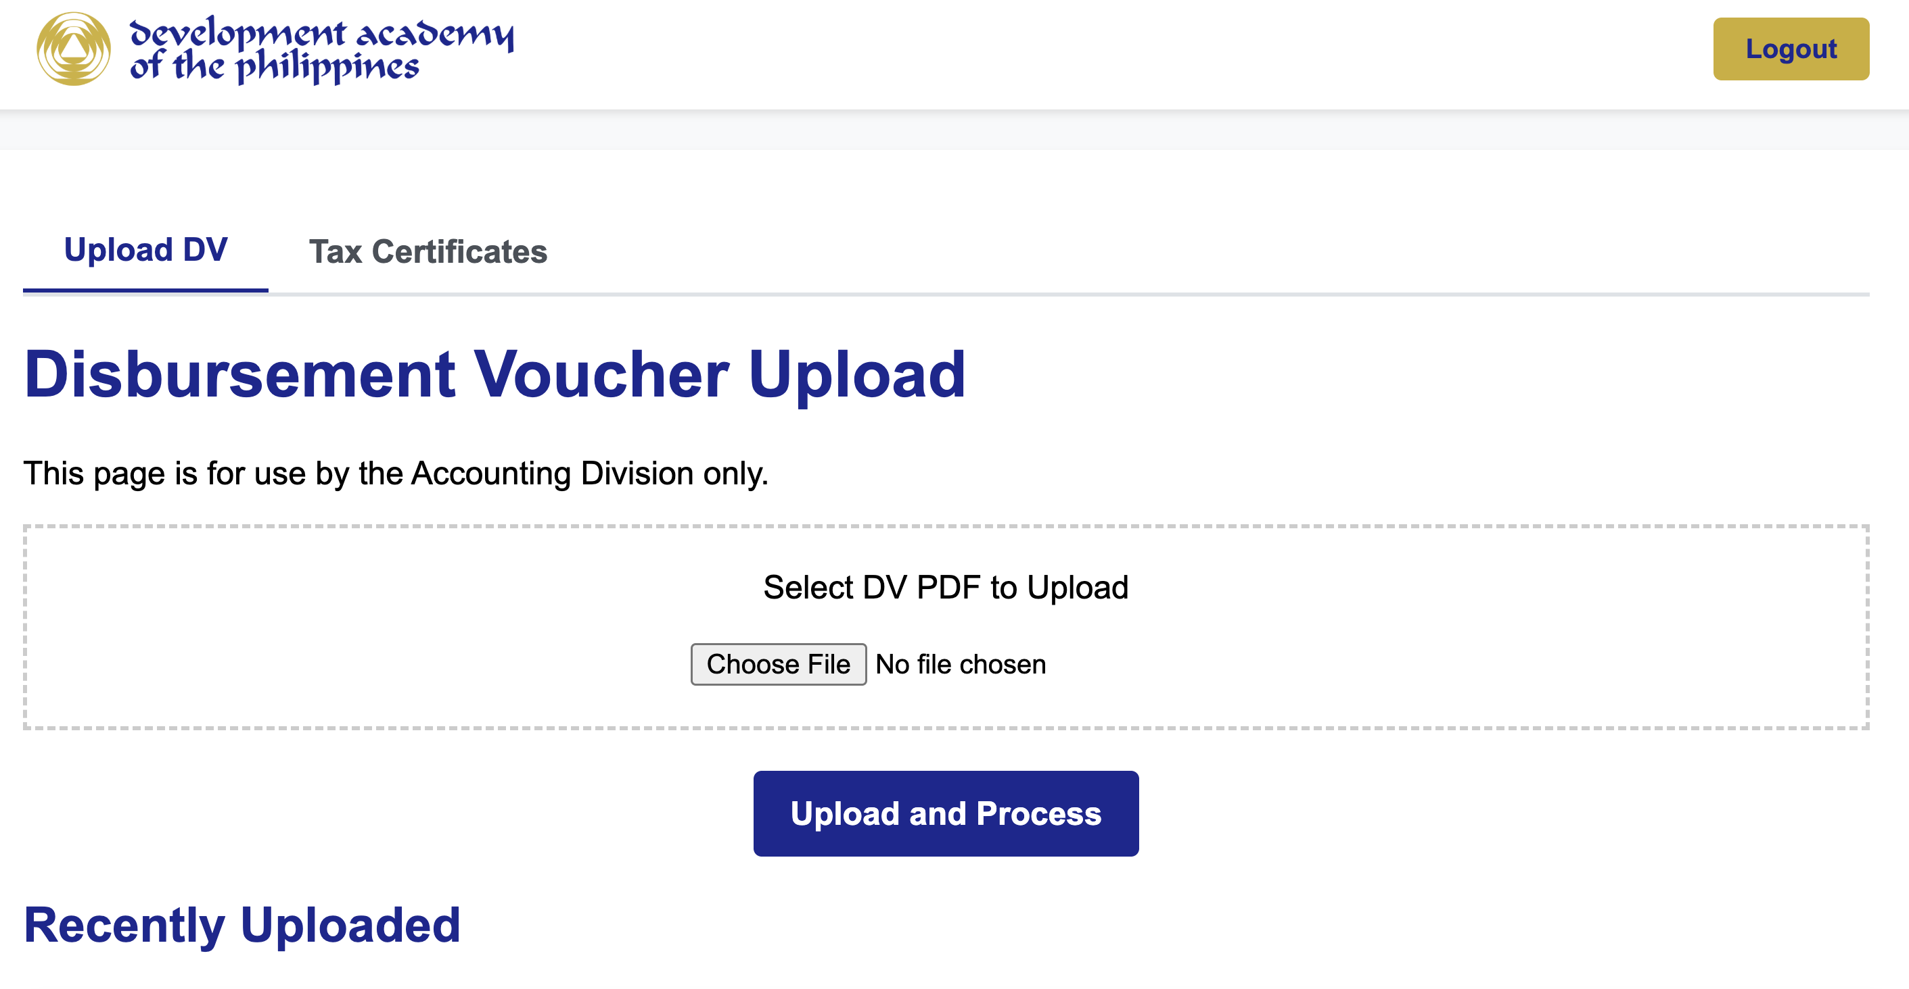
Figure 2. Accounting Web App – Disbursement Voucher Upload

Procedure
- Upload. Log in to the Accounting Web App, open the Upload DV tab, click Choose File, select the DV PDF and click Upload and Process.
- OCR scan. The system converts the PDF to text through the Google Drive API.
- Extraction. Pattern rules extract the Payee Name, Amount, DV Number and Particulars.
- Gatekeeping (automated checks):
  - Payee check – the payee must be enrolled in Payee_Database.
  - Duplicate check – the DV Number must not already exist in the Master_DV_List.
  - Classification – the Transaction Type is assigned from keywords in the particulars (Appendix A).
  - SDO logic – for Petty Cash or Revolving Fund transactions, the SDO_PCF_Accounts sheet is checked.
- Result. If all checks pass, the transaction is added to Master_DV_List as "For Processing" and appears under Recently Uploaded. If a check fails, the upload is stopped and the reason is shown; refer to Section 9.
NOTE: Upload only final, system-generated DVs. Scanned or edited copies may not be read correctly by OCR.

7.2 Stage 2: Tax Compliance – BIR Form 2307 (Parallel Workflow)
Item | Details
Objective | Automate issuance of BIR Form 2307 for professional fees.
Responsible | Accounting Division (reviewing Accountant)
Trigger | Starts automatically when the Transaction Type is "Professional Fee – Resource Person" or "Professional Fee – Consultancy Services".
Output | Signed BIR Form 2307 PDF, queued for delivery with the payment confirmation.

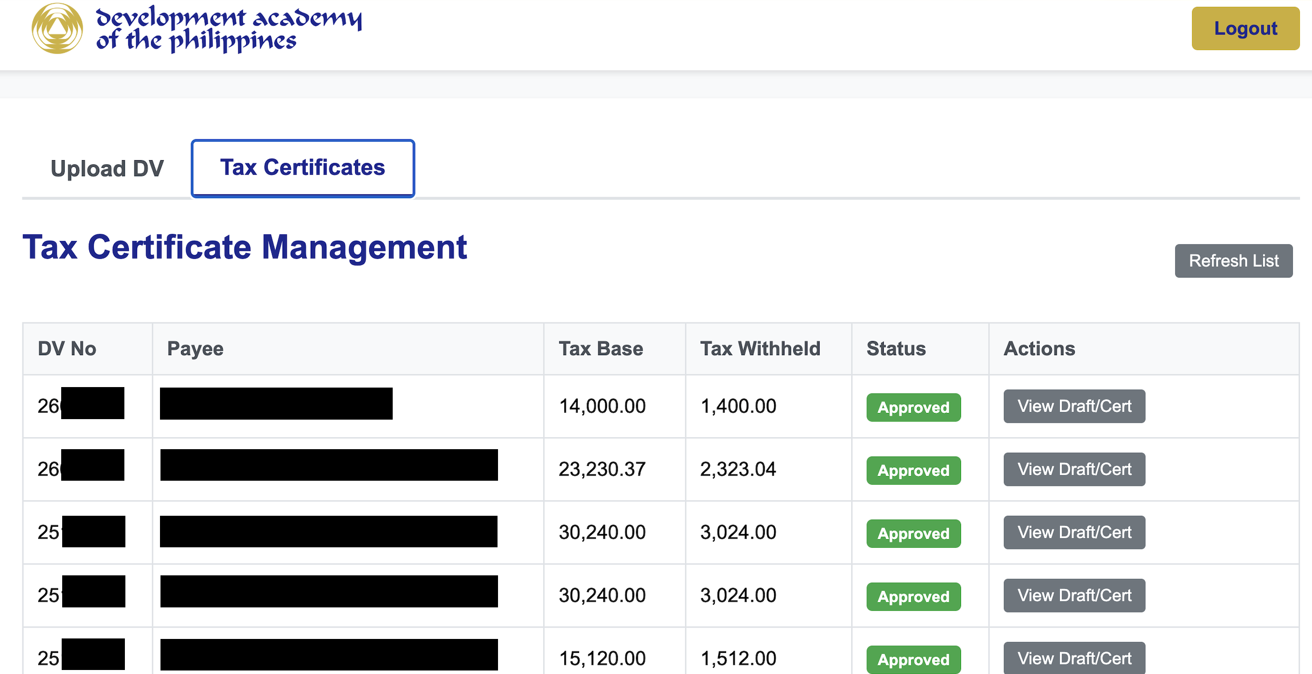
Figure 3. Accounting Web App – Tax Certificate Management

JEV Analysis
The system reads the Journal Entry Voucher table in the DV to identify the Tax Base (from the expense account) and the Tax Withheld (from the EWT account). It computes the effective rate to assign the ATC: 5% maps to WI050 and 10% maps to WI051; any other rate is flagged "REVIEW". The tax period is taken from the calendar quarter of the JEV date. The account codes used are listed in Appendix B.

Approval Loop
- Draft. The system generates a draft BIR Form 2307 PDF from the template.
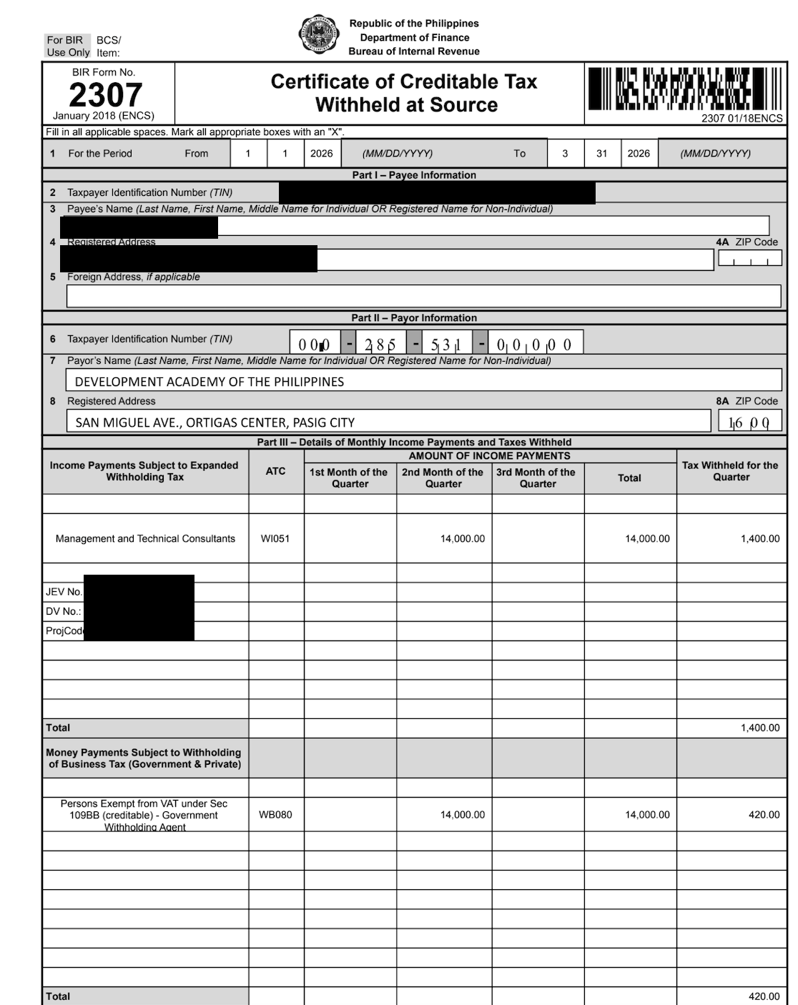
Figure 4. System-generated draft BIR Form 2307
- Notify. The reviewing Accountant receives a "Tax Certificate Approval Request" email with the draft and the original DV attached.
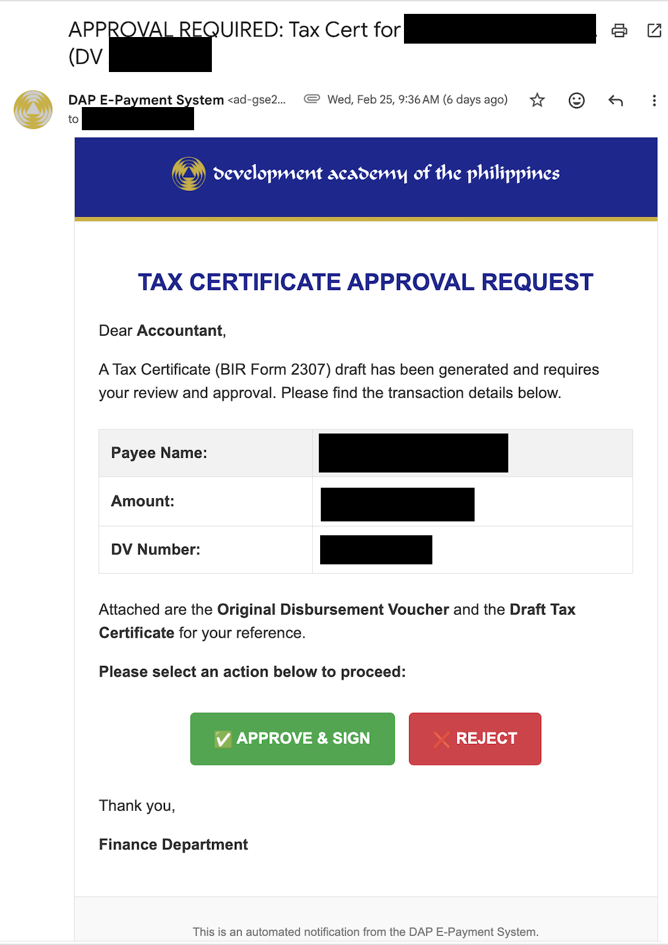
Figure 5. Tax Certificate Approval Request email
- Review and act. The Accountant checks the payee, TIN, amounts, ATC and period, then clicks Approve & Sign (signs and finalizes) or Reject (discards the draft) directly from the email.
- Result. On approval, the signature is applied, the status becomes "Approved", and a confirmation email with the signed copy is sent. The signed PDF is queued for bundling with the payee notification in Stage 5.
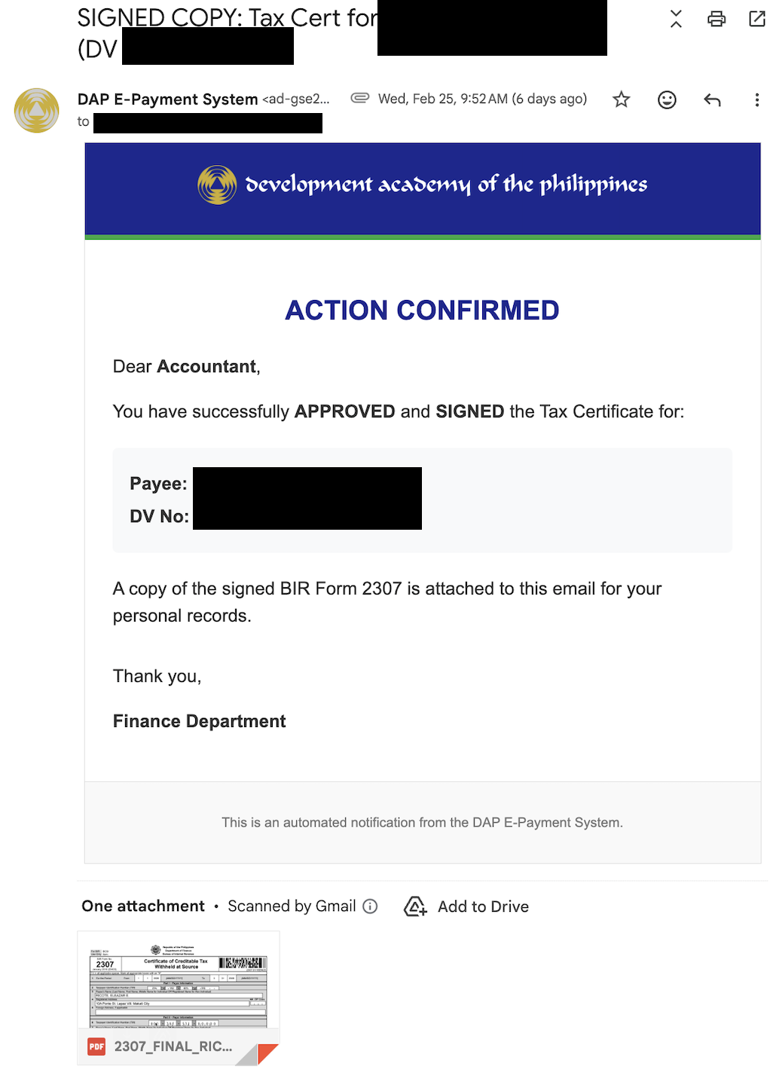
Figure 6. Action Confirmed email with the signed BIR Form 2307
NOTE: All Tax Certificates can be monitored from the Tax Certificates tab (Figure 3) using View Draft/Cert. Use Refresh List to update statuses.

CAUTION: Reject any draft with a blank Tax Base, an ATC of "REVIEW", or figures that differ from the DV. Correct the source DV or template before regenerating.

7.3 Stage 3: Batching (Treasury)
Item | Details
Objective | Group validated transactions for bank processing.
Responsible | Treasury Division
Input | Transactions with status "For Processing".
Output | Batch with a unique Batch No.; transactions set to "Batched for Approval".

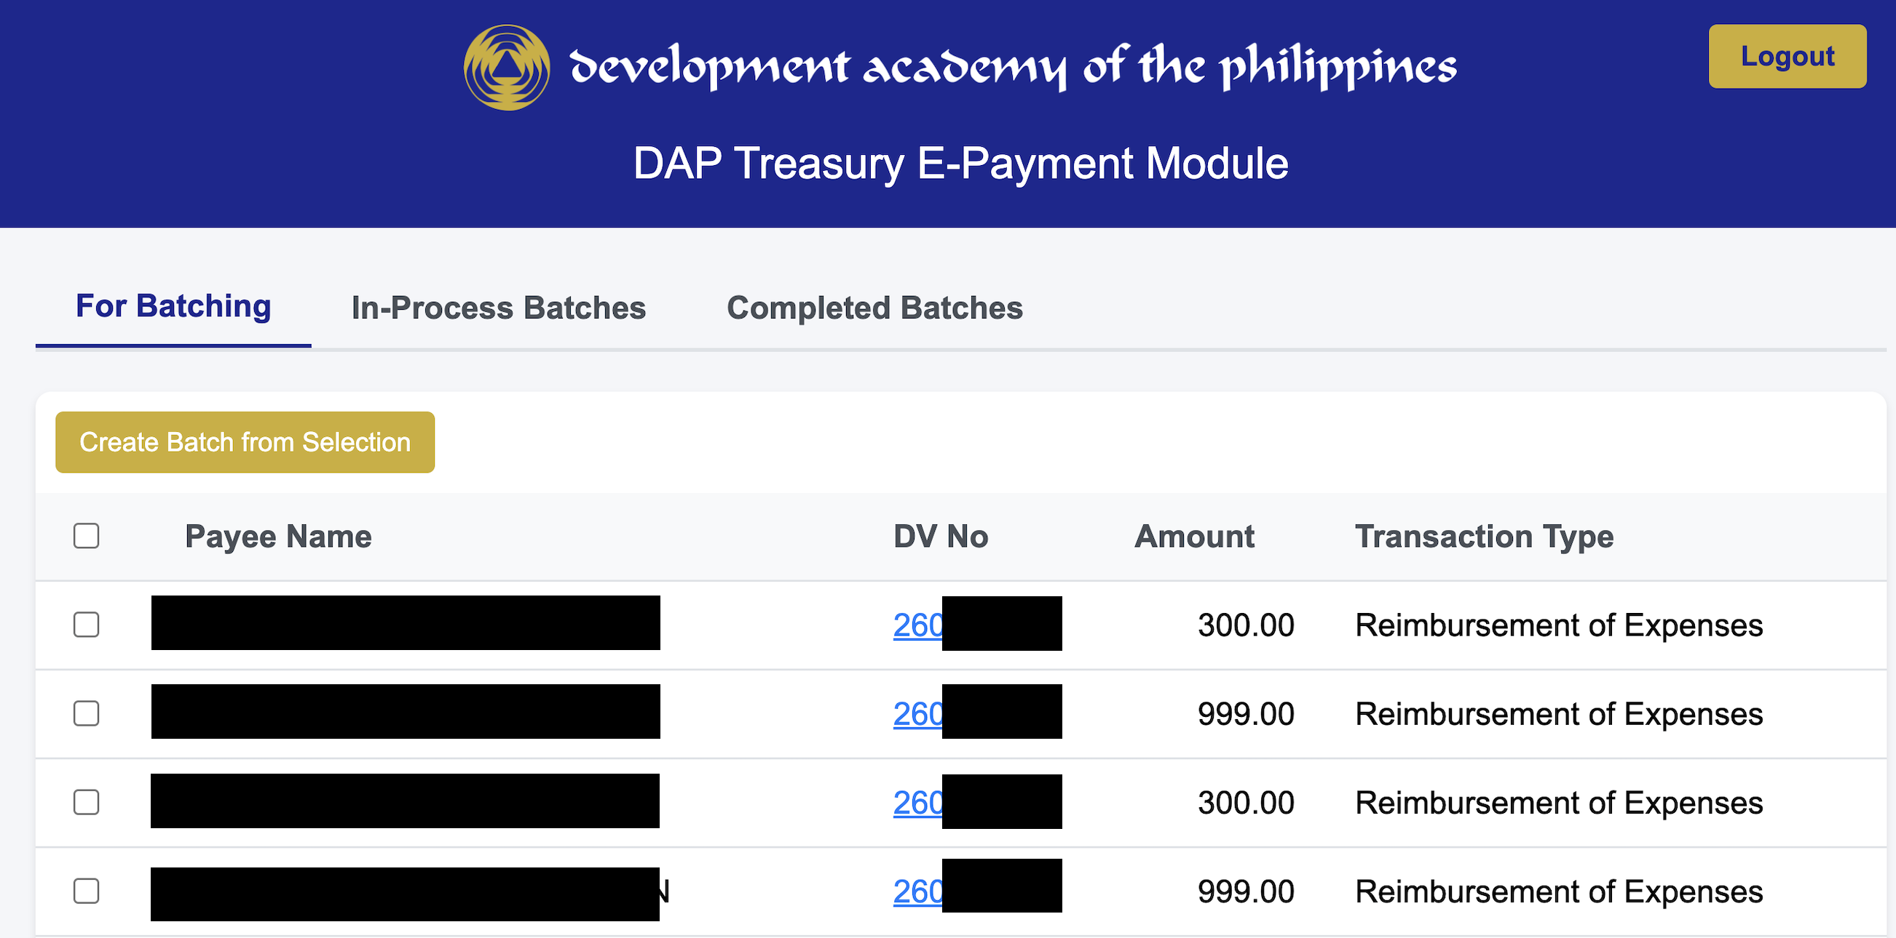
Figure 7. Treasury Hub – For Batching tab
- Log in to the Treasury Hub and open the For Batching tab.
- Review the list and tick the checkbox of each transaction to include. Confirm payee, DV No., amount and transaction type against the physical or approved DV.
- Click Create Batch from Selection.
- Result: The selected transactions are locked, assigned a Batch ID (e.g., 2026-01-0015 = 15th batch of January 2026), and moved to the In-Process Batches tab with status "Batched for Approval".
NOTE: Large batches should be kept to about 50 items to stay within Google Apps Script execution limits (see Section 10).

7.4 Stage 4: The Bridge – Bank Interoperability
Objective: Securely transfer data to LANDBANK WeAccess and verify its integrity before any fund transfer is approved.

Step 4A: FINDES Generation
- In In-Process Batches, select the batch and click Generate FINDES.
- The system builds the CSV in the strict format required by LANDBANK (Appendix C), choosing the correct account for each payee (applying the SDO override where applicable).
- Safety check: account numbers of 7 digits or fewer stop the process with an alert; 8- or 9-digit numbers are padded with leading zeros to 10 digits.
- The FINDES CSV is saved to the batch folder in Drive and the status changes to "FINDES Generated".
- Download the file and upload it to LANDBANK WeAccess under the ATM Payroll facility. Record the TRN issued by the portal.
CAUTION: Never edit the FINDES file by hand. If a correction is needed, fix the source record (Payee_Database or Master_DV_List) and regenerate the file.

Step 4B: Verification (The "Anti-Fraud" Layer)
- Download the Payroll Register PDF produced by WeAccess after the upload.
- In the Treasury Hub, open the endorsement dialog for the batch, enter the WeAccess TRN and upload the Payroll Register.
- The system OCR-reads the bank's PDF and compares it line by line with the batch data. Validation rules:
  - The total amount must match.
  - The transaction count must match.
  - Every payee and account number in the register must exist in the batch.
  - Each payee's amount must match.
- Mismatch: the process stops and a detailed list of discrepancies is displayed. Do not proceed in WeAccess; investigate and correct before re-uploading.
- Match: the process continues automatically to endorsement.

Step 4C: Endorsement
Once validation passes, the system saves the Payroll Register to the batch folder, sets the batch status to "Pending WeAccess Approval", and emails the Authorized Signatories a Request for WeAccess Approval. The email contains the Batch Number, WeAccess TRN, total records and amount, a payee-level breakdown, a Login to WeAccess button, step-by-step approval instructions, and the Payroll Register and supporting DVs as attachments.
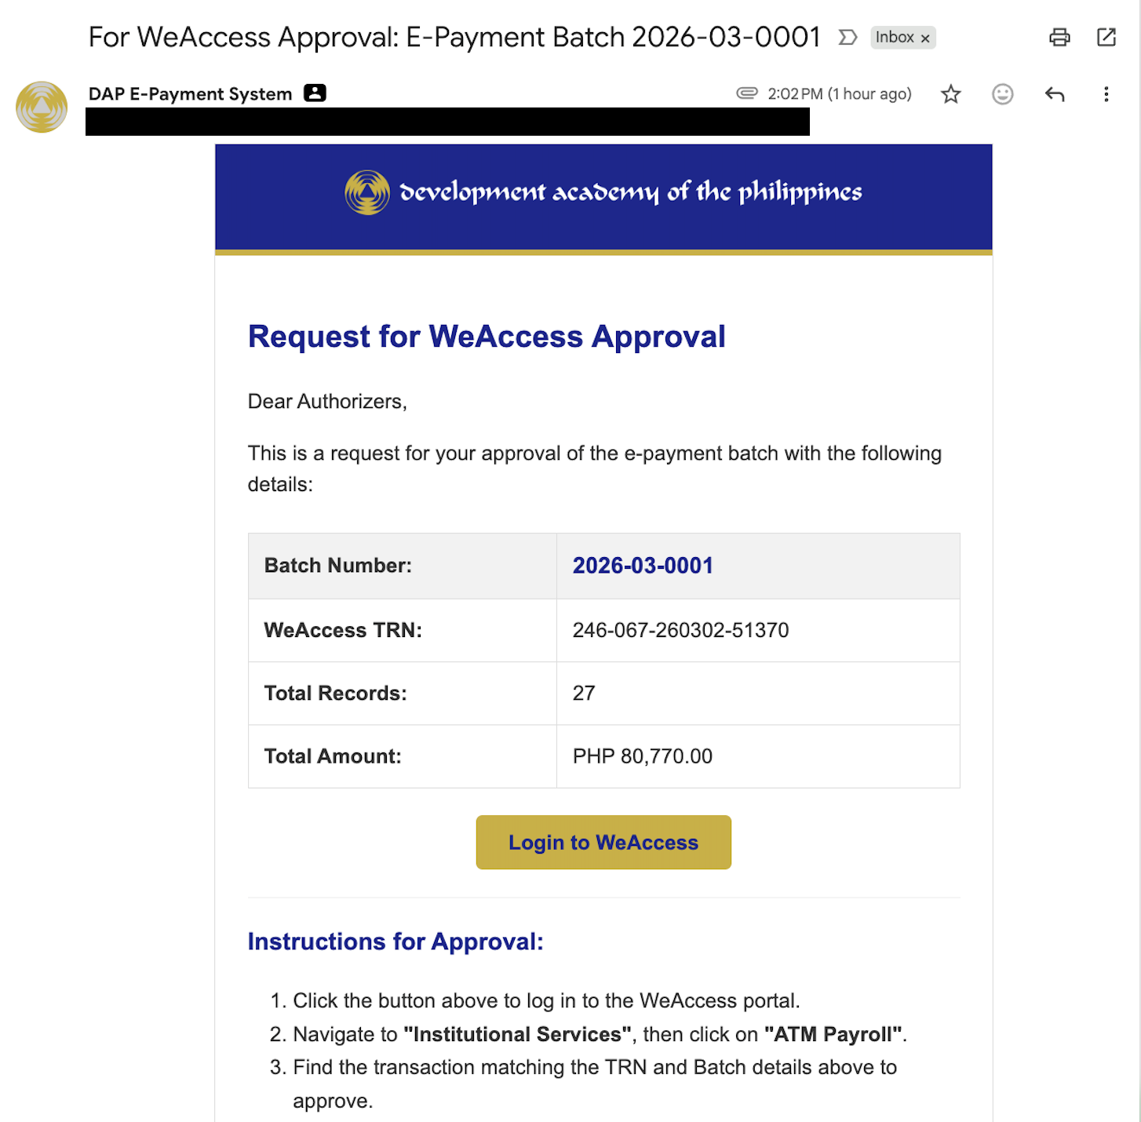
Figure 8. Request for WeAccess Approval email sent to Authorized Signatories
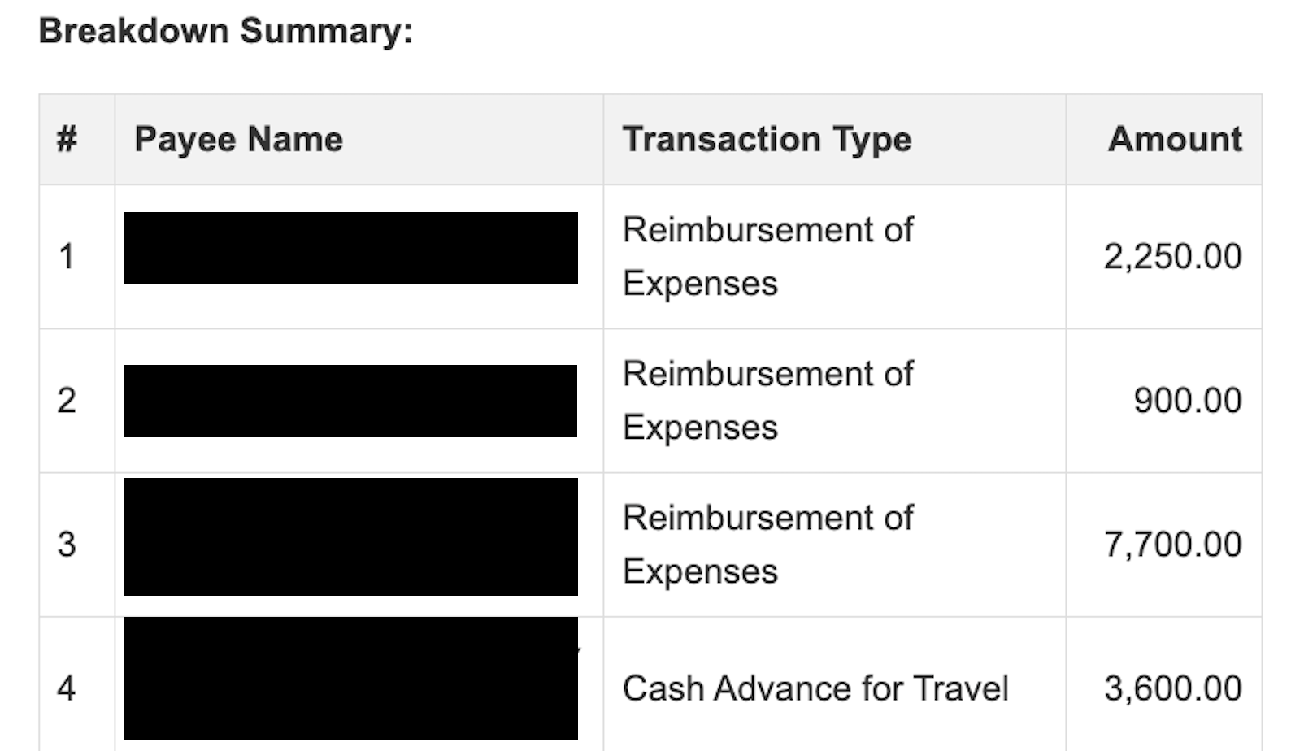
Figure 9. Endorsement email – Breakdown Summary
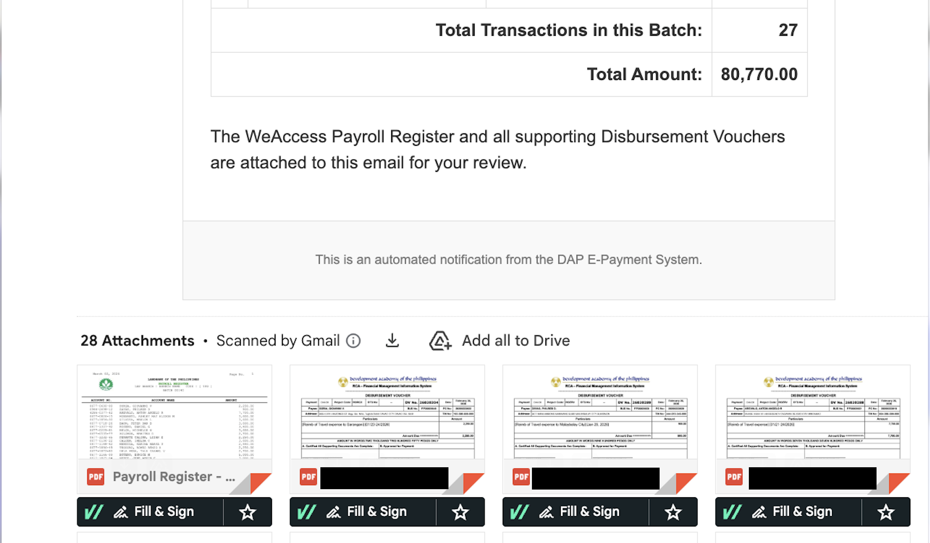
Figure 10. Endorsement email – batch totals and attached Payroll Register and DVs
Signatories approve the transaction in WeAccess by navigating to Institutional Services > ATM Payroll and selecting the transaction that matches the TRN and batch details.

7.5 Stage 5: Finalization and Payout (Treasury)
Item | Details
Objective | Close the batch and notify payees.
Responsible | Treasury Division
Prerequisite | Fund transfer approved in WeAccess; Debit Memo available.
Output | Annex H; payee emails; status "Approved & Emailed".

- Once the bank approves the fund transfer, open the batch in the Treasury Hub and click Finalize Batch. Upload the bank's Debit Memo when prompted.
- Annex H. The system generates the official Daily Report of E-Payments (Annex H) PDF from the template and saves it to the batch folder.
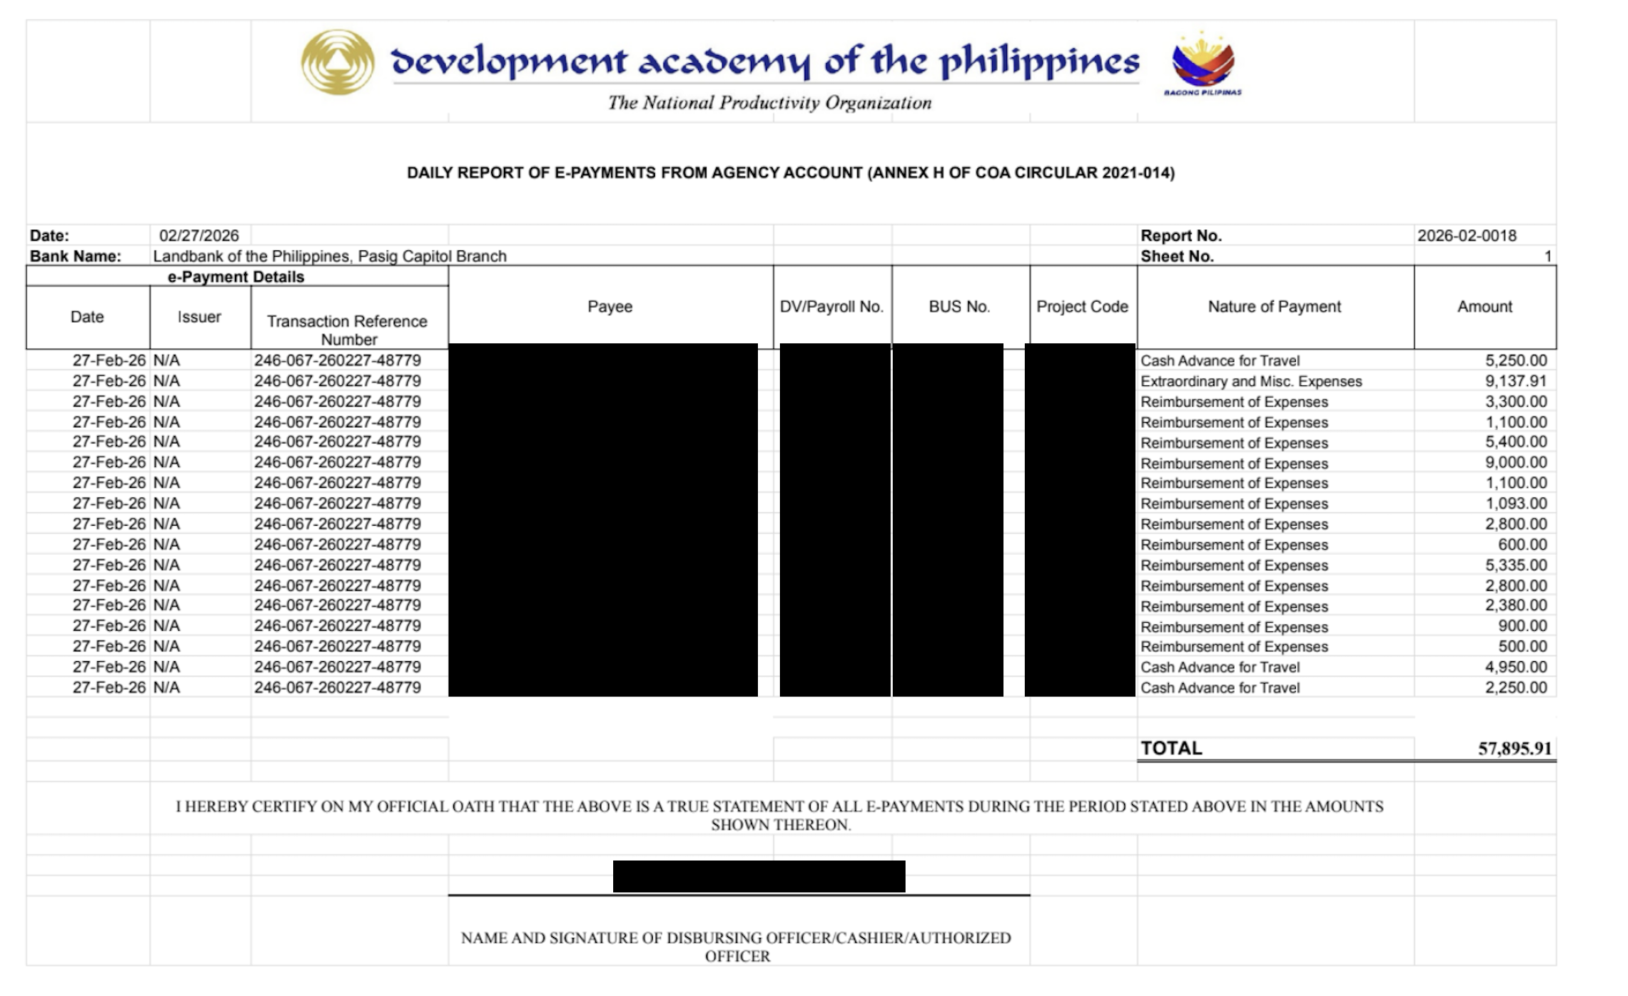
Figure 11. System-generated Annex H – Daily Report of E-Payments from Agency Account
- Payee notification. Every payee in the batch receives a Fund Transfer Confirmation email stating the amount, purpose, DV number and the last digits of the account credited.
  - Attachments: the original DV PDF and, for professional fees, the signed BIR Form 2307.
  - Feedback loop: a link to the CSM Survey with instructions specific to the transaction type.
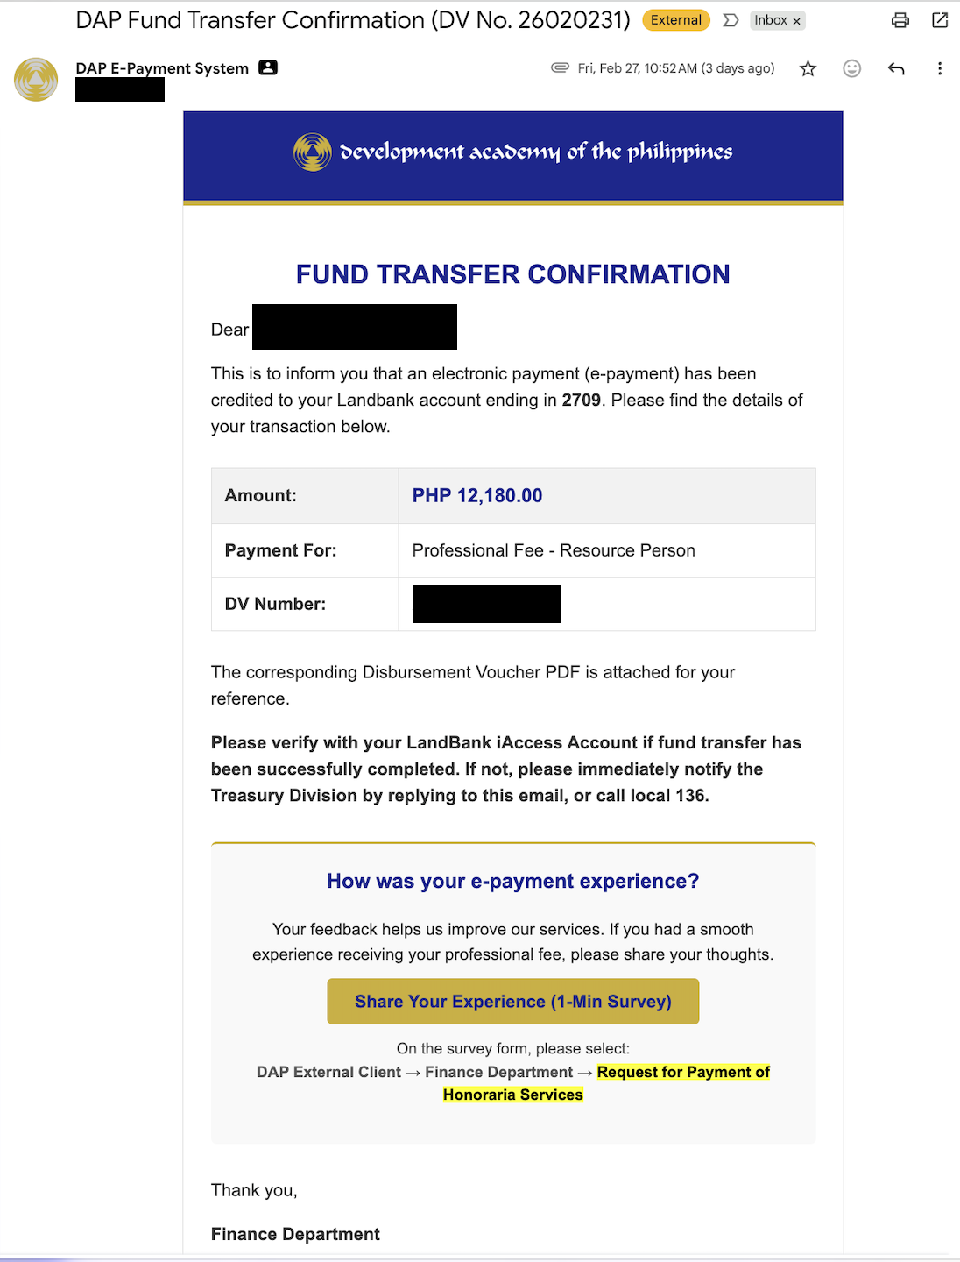
Figure 12. Fund Transfer Confirmation email received by the payee
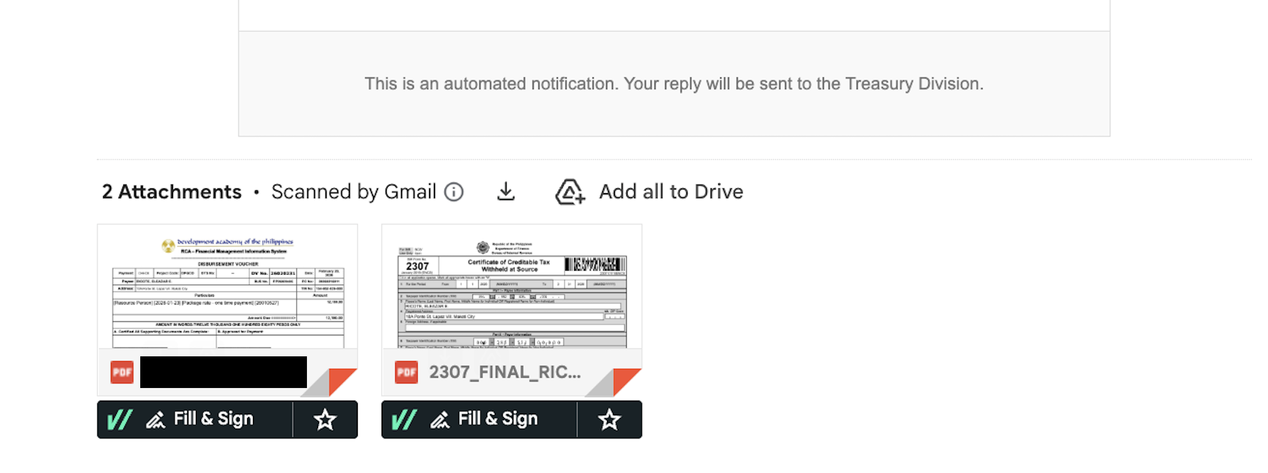
Figure 13. Payee email attachments – Disbursement Voucher and signed BIR Form 2307
The status of all transactions in the batch changes to "Approved & Emailed" and the batch moves to the Completed Batches tab.

7.6 Stage 6: Recording – Handoff to Accounting
Item | Details
Objective | Turn over completed records to the Accounting Division for JEV recording.
Responsible | Treasury Division (sends); Accounting Division (records)
Prerequisite | Batch status is "Approved & Emailed".
Output | "For Recording" email; status "Completed".

- In Completed Batches, click Notify Accounting for the batch.
- The system bundles the Accounting Summary CSV, Annex H, Debit Memo, FINDES file and all DVs of the batch.
- The package is emailed to the Accounting Division with the subject "For Recording: E-Payment Batch [Batch No.]" and the suggested JEV particulars.
- All transactions in the batch are marked "Completed".
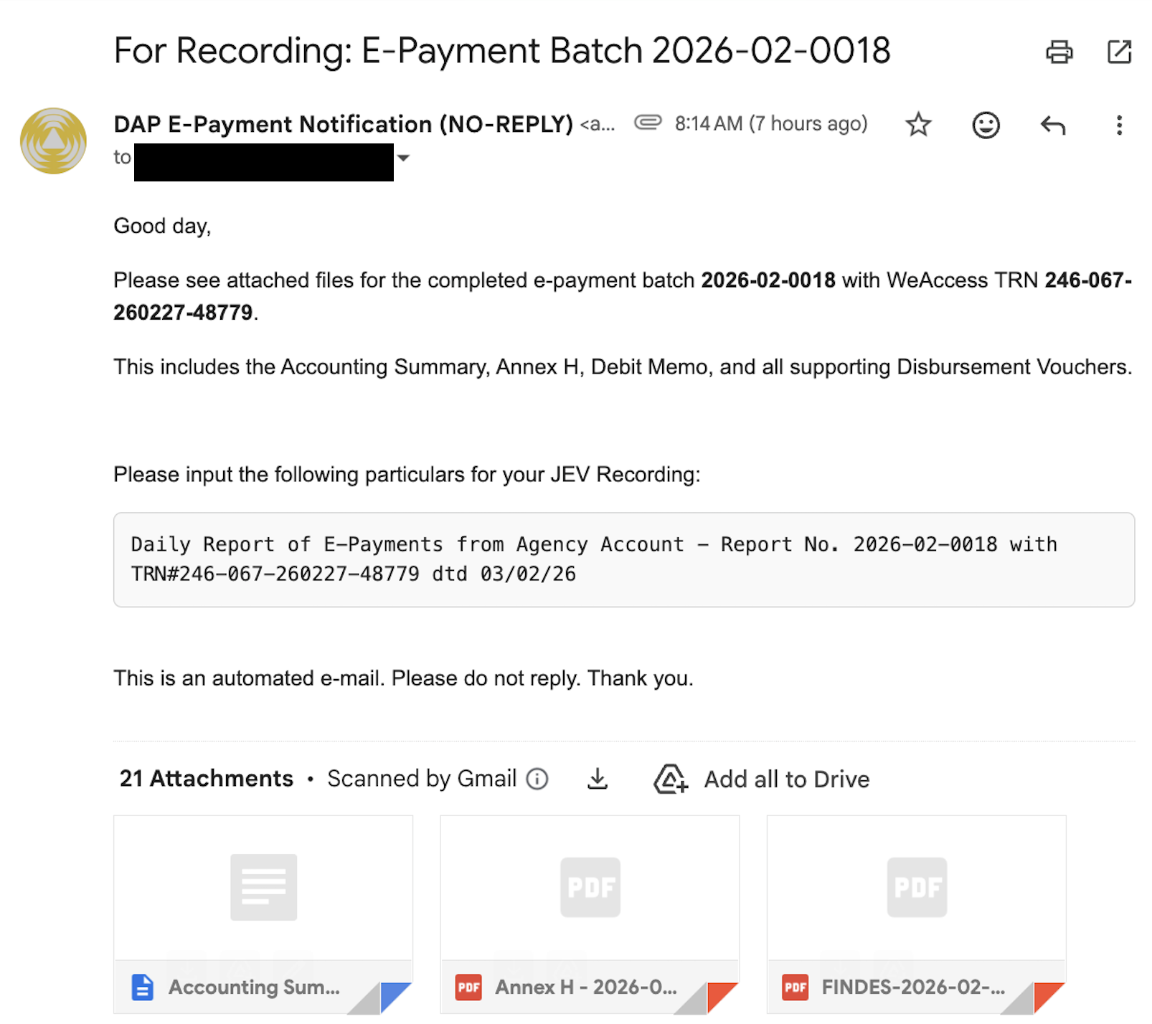
Figure 14. For Recording email with the batch package

8. Protocols and Sub-Systems

8.1 The SDO "Ghost" Protocol
To prevent commingling of personal and public funds, the system selects the destination account based on the nature of the transaction, not only on the payee name:
Scenario | Example | Account Credited
A. Personal claim | Juan Dela Cruz claims "Reimbursement of Expenses". | Personal payroll account (from Payee_Database).
B. Custodial fund | Juan Dela Cruz claims "Replenishment of Petty Cash Funds" or "Establishment of Revolving Fund". | Custodial PCF account (from SDO_PCF_Accounts).

If an SDO transaction has no custodial account on file, the system alerts Treasury before using the personal account so the user can confirm or stop. New SDO accounts are registered by the Administrator under SDO Management in the Admin Dashboard.

8.2 Payee Enrollment System
Only enrolled payees can be paid through the system. Enrollment follows a three-level review to make sure each account belongs to the right person.
- Request. The payee, or the staff member endorsing them, fills out the DAP LandBank Account Enrollment Google Form and uploads the signed Declaration of Landbank Account Details (Annex A) and proof of the bank account.
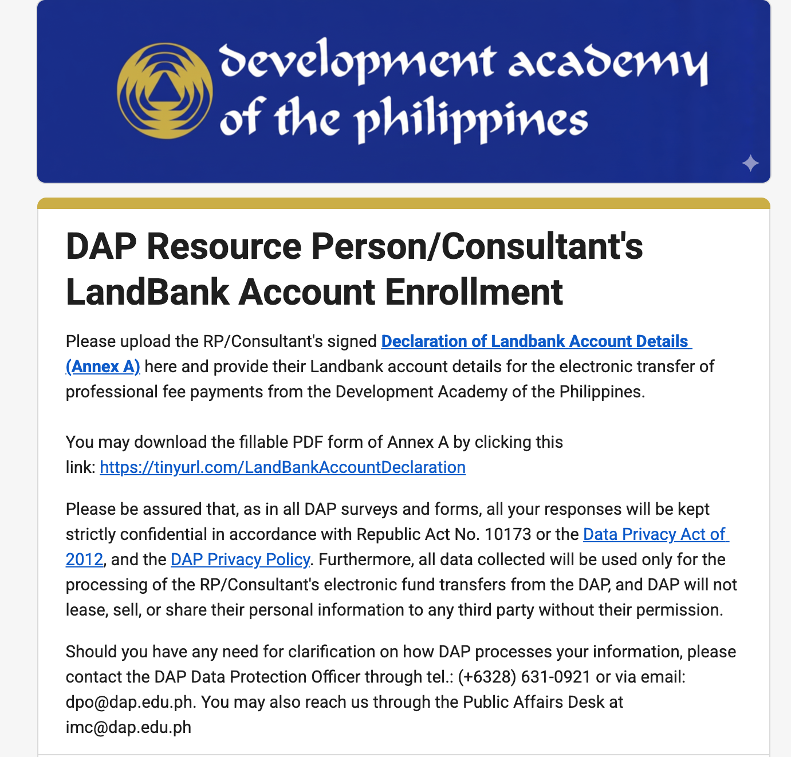
Figure 15. DAP Resource Person/Consultant's LandBank Account Enrollment form
- HR validation. HR opens the External Enrollment tab of the Admin Dashboard (status "Pending HR Validation"), clicks View, checks the supporting documents, adds the HRIS Name and HRIS No., then clicks Submit to Admin.
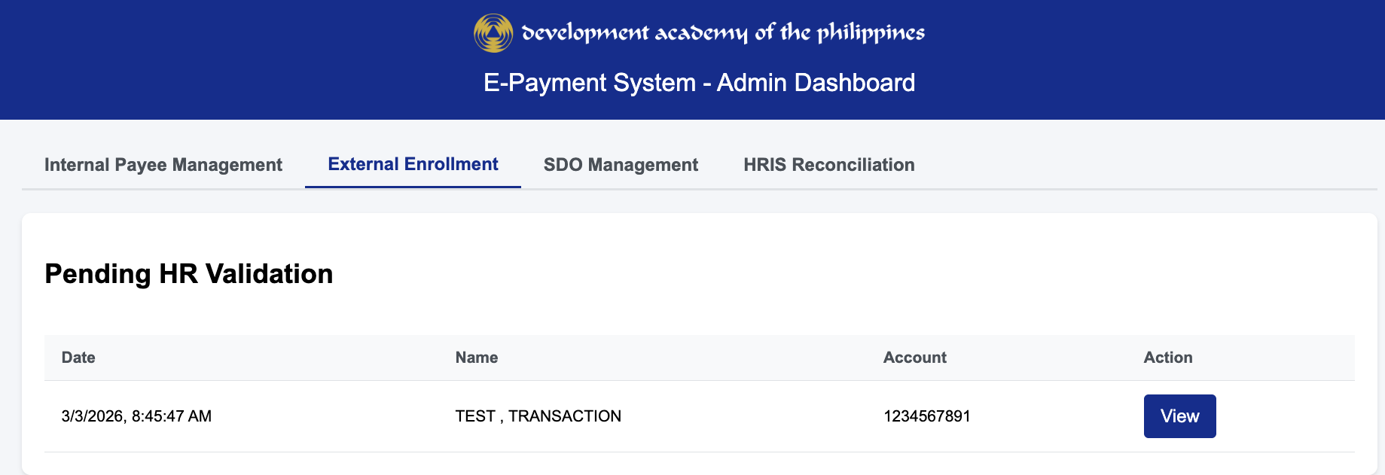
Figure 16. Admin Dashboard – External Enrollment, Pending HR Validation
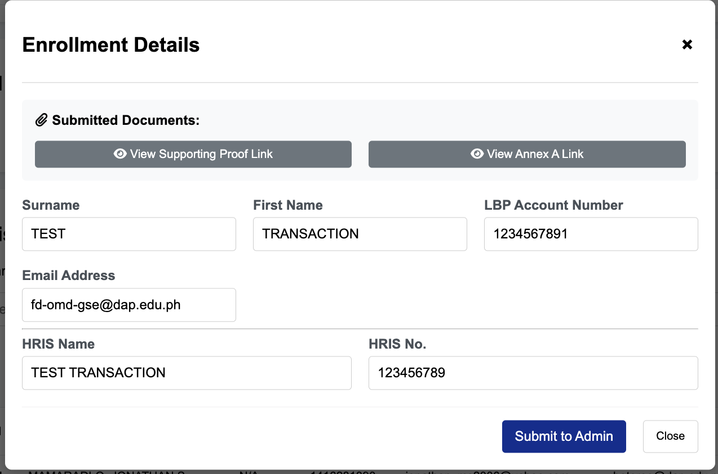
Figure 17. Enrollment Details – HR submission to Admin
- Admin approval. The System Administrator reviews the request (status "Pending Final Approval") and clicks Approve & Enroll to commit it to Payee_Database, or Reject with a reason. The endorser is notified of any rejection.
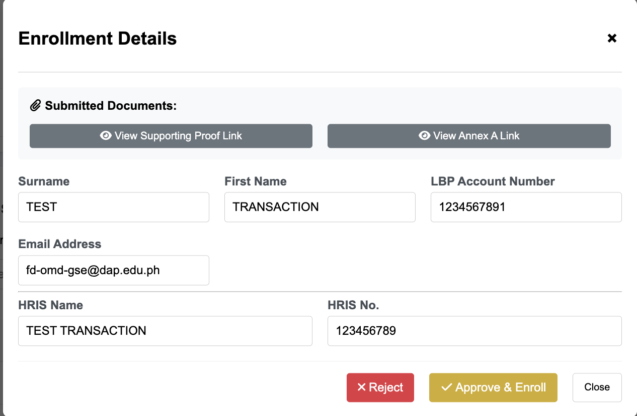
Figure 18. Enrollment Details – Admin approval
- Notification. The payee receives a Notice of Successful Enrollment email confirming the enrolled name, account number and registered email.
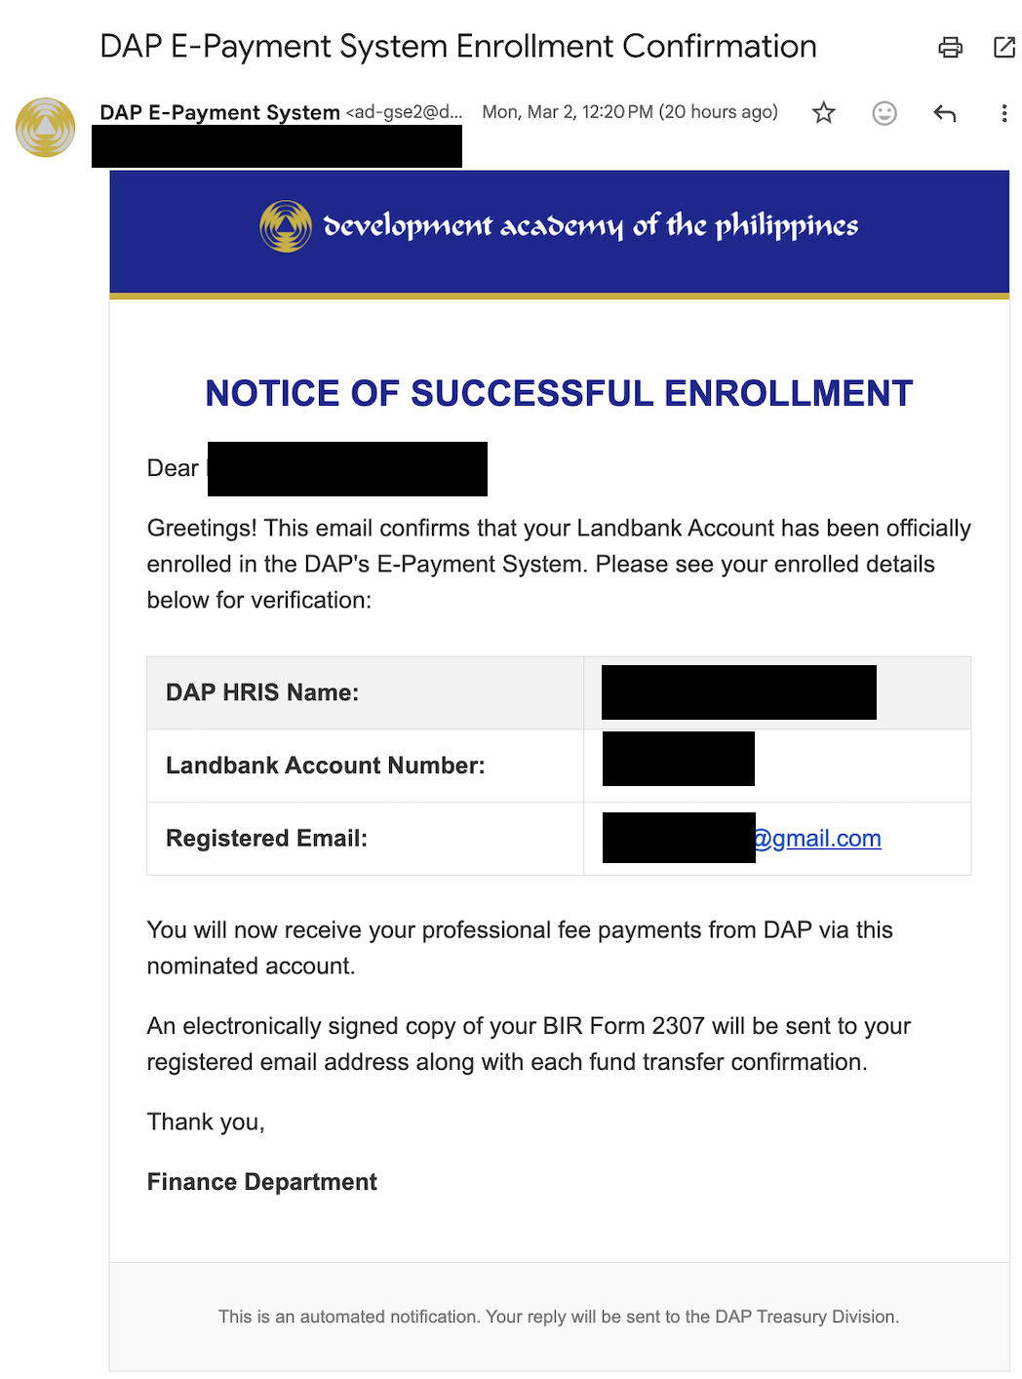
Figure 19. Notice of Successful Enrollment email

8.3 Internal Payee Management and HRIS Reconciliation
Employees are maintained by the Administrator in the Internal Payee Management tab, where payees can be added or updated. The HRIS Reconciliation tab compares an HRIS payroll export with Payee_Database, lists new employees and changed account numbers, and commits approved changes in one locked operation.

8.4 Security and Authentication
Control | Description
Session management | Login tokens are held in CacheService and expire after 8 hours.
Password hashing | Passwords are stored only as SHA-256 hashes with a unique salt per user.
Logout blocklist | Logging out invalidates the token immediately.
LockService | Database writes are locked to prevent race conditions (e.g., two admins approving the same payee at once).
Account status | Only users with status "Active" in User_Database can log in.
Bank separation | The system never stores WeAccess credentials; fund transfer approval happens only inside the bank portal.

CAUTION: Do not share passwords or session links. A dashboard URL contains a session token and grants access until it expires.

9. Troubleshooting Guide
Issue | Likely Cause | Solution
"Duplicate Found" error | The DV Number has already been uploaded. | Check Master_DV_List for the existing entry. If it is a deliberate re-upload, ask the Administrator to delete the old row first.
"Payee Not Enrolled" | The payee is not in Payee_Database, or the name on the DV is spelled differently. | Enroll the payee (Section 8.2) or make sure the name on the DV matches the database exactly. The system ignores special characters.
Tax Certificate is blank | The JEV table in the DV uses an account code the system does not recognize. | The system looks for specific account codes (Appendix B). If the DV uses a new code, ask the Administrator to add it.
ATC shows "REVIEW" | The withholding rate is not 5% or 10%. | Check the DV computation. Reject the draft and process the 2307 manually if a different rate applies.
"Account number suspiciously short" | Account in Payee_Database has 7 digits or fewer. | Verify the account with the payee's bank proof and correct it in the database, then regenerate FINDES.
Validation mismatch (Stage 4) | The bank's Payroll Register differs from the batch, or the PDF is incomplete. | Make sure the full Payroll Register PDF (all pages) was uploaded. Compare the listed discrepancies and correct the batch or the WeAccess upload.
"Could not find the WeAccess Reference Number" | Endorsement was not completed for the batch. | Complete Step 4B/4C for the batch before finalizing.
Script timeout | Batch too large for the 6-minute execution limit. | Split the batch into smaller batches of about 50 items.
Login failed | Wrong password or inactive account. | Contact the Administrator to reset the password or check the User_Database status.
Email not received | Wrong email in Payee_Database, or message filtered as spam. | Verify the address in the database and ask the recipient to check their spam folder.

10. Maintenance and Configuration

10.1 System Limits
- Script execution limit: Google Apps Script stops any single run after 6 minutes. OCR tasks are optimized, but very large batches (more than 50 items) should be split if timeouts occur.
- Email quota: Google Workspace limits the number of emails sent per day. Spread very large payment runs across the day if needed.

10.2 Folder Structure
The system creates Drive folders automatically. Do not manually move or rename the Year, Month or Batch folders; the scripts locate files by these names.

10.3 Templates
The system uses Google Sheet templates for Annex H and BIR Form 2307. Their file IDs are set in the script and Config sheet and must remain valid. When a template is replaced (for example, a new BIR revision), update the ID and test with a sample DV before going live.

10.4 Routine Maintenance Schedule
Frequency | Task | Responsible
Daily | Check that all "For Processing" items are batched and no batch remains in "Pending WeAccess Approval" without action. | Treasury
Weekly | Review Tax_Cert_Data for drafts left unapproved or rejected. | Accounting
Monthly | Run the archiving routine: completed transactions older than 30 days are moved from Master_DV_List to an archive spreadsheet in the Archive folder. | Admin
Monthly | Run HRIS Reconciliation to capture new employees and account changes. | Admin / HR
Quarterly | Review User_Database; deactivate accounts of separated or reassigned staff. | Admin
As needed | Update account codes, templates, signatories and email recipients. | Admin

10.5 Business Continuity
If the system is unavailable, Treasury may revert to manual encoding in WeAccess with the approval of the Chief, Treasury Division. Transactions processed manually must be recorded in the Master_DV_List afterwards with a remark, so that the ledger remains complete.

11. Data Privacy and Records Management
The system processes personal information of employees, resource persons and consultants, including names, bank account numbers, TINs and email addresses. All users must handle this information in accordance with Republic Act No. 10173 (Data Privacy Act of 2012) and the DAP Privacy Policy.
- Access the system only for official transactions assigned to your role.
- Do not download or forward payee data outside official channels.
- Report any suspected data breach immediately to the DAP Data Protection Officer (dpo@dap.edu.ph).
- Records in Drive and the archive spreadsheets are kept in line with COA and National Archives retention rules for financial records.

Appendix A. Transaction Type Classification
Transaction types are assigned from keywords in the DV particulars, checked in the order below. The first match applies.
Keyword in Particulars | Transaction Type Assigned
EME | Extraordinary and Misc. Expenses
liq/reim of CA, liq/reimb of CA | Liquidation/Reimbursement of Cash Advance
reimb | Reimbursement of Expenses
petty cash | Replenishment of Petty Cash Funds
cash advance + travel | Cash Advance for Travel
cash advance | Cash Advance for Specific Purposes
cash payroll | Cash Payroll
establishment of revolving fund | Establishment of Revolving Fund
salary differential - promotion | Special Payroll: Salary Differential due to Promotion
clothing allowance | Special Payroll: Clothing Allowance
CPCS | Special Payroll: Salary Differential due to CPCS Implementation
resource person | Professional Fee – Resource Person
consultancy | Professional Fee – Consultancy Services
loyalty | Loyalty Pay
NPP | Unclaimed Salary – NPP
COS | Unclaimed Salary/Overtime Pay – COS
refund | Refund of Payment
(none of the above) | Unclassified

Appendix B. JEV Account Codes and ATC Mapping
Account Code | Account Title | Used For
5-02-11-990-01 | Other Professional Services | Tax Base
5-02-02-010-01 | Training Expenses | Tax Base
5-02-11-030-01 | Consultancy Services | Tax Base
2-02-01-010-02 | Due to BIR – Expanded Withholding Tax | EWT Amount
2-02-01-010-06 | Due to BIR – Government Money Payment (VAT) | VAT Amount
2-02-01-010-09 | Due to BIR – Percentage Tax | Percentage Tax Amount

EWT ÷ Tax Base | ATC Assigned
5% | WI050
10% | WI051
Any other rate | REVIEW (manual check required)

Appendix C. FINDES File Format
The FINDES file is a plain CSV with one line per payee and no header row:
"ACCOUNT NUMBER","PAYEE NAME",AMOUNT
Field | Rule
Account Number | 10 digits, enclosed in quotes. 8–9 digit values are padded with leading zeros; 7 digits or fewer is rejected.
Payee Name | Uppercase, enclosed in quotes. Periods, apostrophes, hyphens and commas after the surname are removed; Ñ is converted to N; extra spaces are removed.
Amount | Amount in centavos without a decimal point (e.g., PHP 2,250.00 is written as 225000).

Example: "0123456789","DELA CRUZ, JUAN P",225000
— End of Document —

